**Binary Tree [CO2]**

Instructions for students:

● Complete the following methods on Tree.

● You may use any language to complete the tasks.

● All your methods must be written in one single .java or .py or .pynb file. DO NOT CREATE separate files for each task.

● If you are using JAVA, you must include the main method as well which should test your other methods and print the outputs according to the tasks.

● If you are using PYTHON, then follow the coding templates shared in this folder.

NOTE:

**● YOU CANNOT USE ANY BUILT-IN FUNCTION EXCEPT** len **IN PYTHON. [negative indexing, append is prohibited]**

**● YOU HAVE TO MENTION SIZE OF ARRAY WHILE INITIALIZATION**

**● YOUR CODE SHOULD WORK FOR ALL RELEVANT SAMPLE INPUTS**

* **DO NOT USE LIST, QUEUE**

## Mirror Tree:

Given a binary tree, convert it into its mirror.

Sample Input:

10

/ \

20 30

/ \

40 60

Sample Output:

10 10

/ \ Mirror / \

20 30 —> 30 20

/ \ / \

40 60 60 40

Inorder Traversal of mirror: 30 10 60 20 40

## Level Min:

Given a binary tree, find the smallest value in each level.

Sample Input: [You can use a dictionary here]

4

/ \

9 2

/ \ \

3 -5 7

Sample Output: 4 2 -5

Explanation:

There are 3 levels in the tree

Level 0: {4}, min= 4

Level 1: {2, 9}, min= 2

Level 2: {7, 3, -5}, min = -5

## 

## Sum of Nodes:

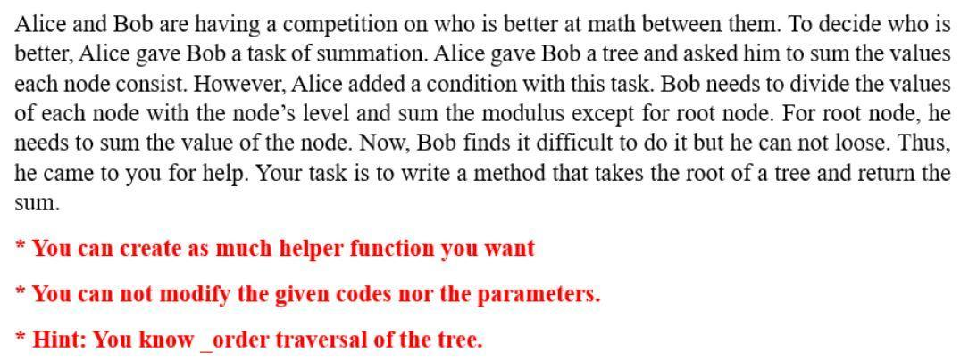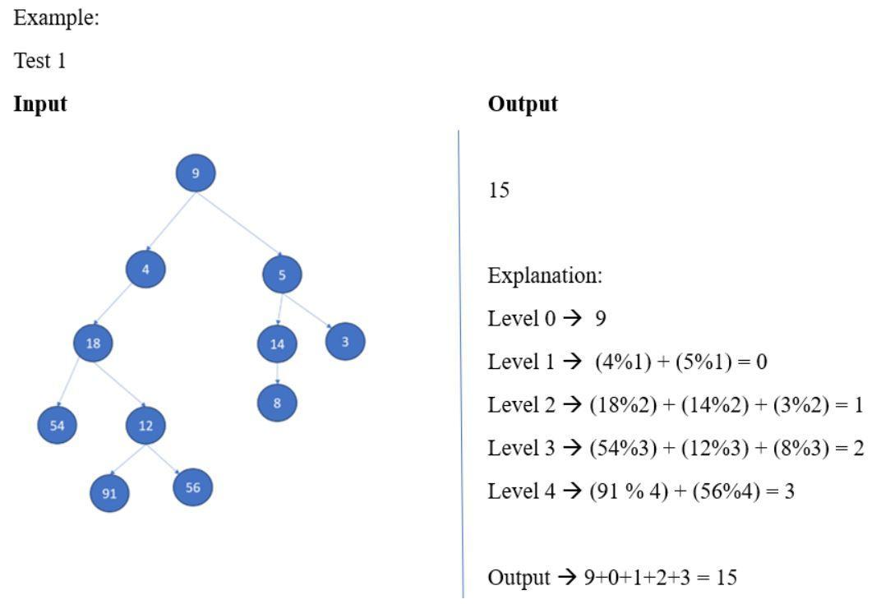

1. Swap Children Nodes:

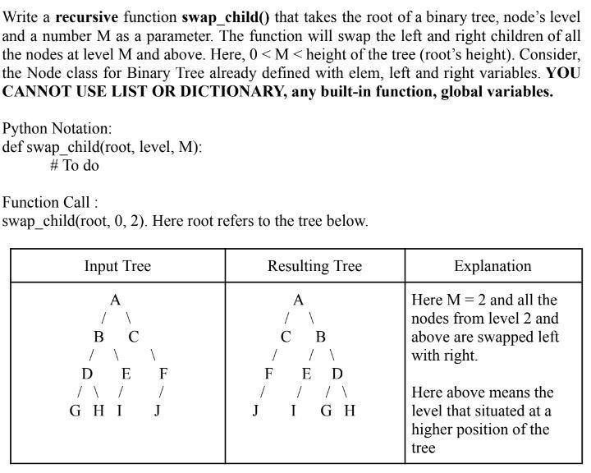

## Subtraction of Nodes:

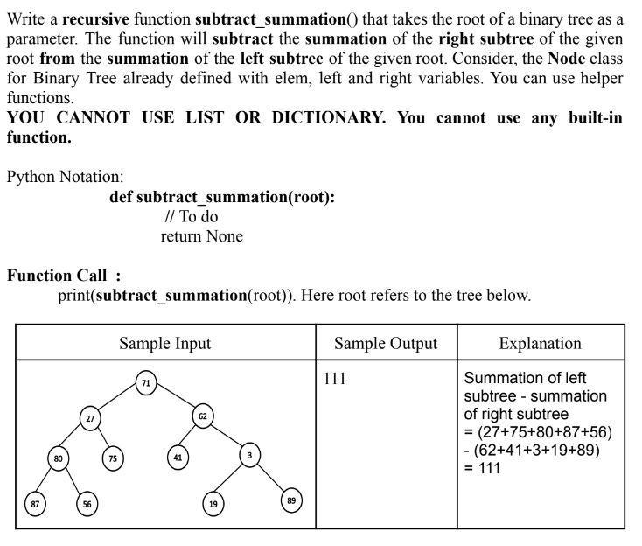

## 

## 

## 

## Bonus Task: Difference of Level Sum

Given a Binary Tree, Write a function that finds the difference between sum of all nodes present at odd and even levels in a binary tree, i.e. sum of all odd level nodes - sum of all even level nodes.

| Sample Input: | Sample Output | Explanation |
| --- | --- | --- |
|  | 4 | -1+2+3-4-5-6+7+8 = 4 |